**From:** Huxley Rust  
**Date:** 25/06/2025  
**Subject:** A lotta math (i.e., Mesh Analysis Using Laplace of a Two-Loop RC Circuit)

**Introduction:**

This memo summarizes the findings of our experiment investigating the transient response of a two-loop RC circuit when exposed to a step voltage. We were able to track the voltage and current rising and decaying using both an oscilloscope as well as some sick math skillz (Laplace & Mesh Analysis) which allowed us to convert a time domain circuit into a frequency domain circuit which was then simplified and equations were then extrapolated to allow us to plot the changes in voltage and current over time.

**Circuit Analysis and Calculations:**

1. **Measured Component Values:**

|  |  |  |  |
| --- | --- | --- | --- |
|  | **Expected** | **Measured** | **% Error** |
| **Capacitor** | *10 µF* | *10.2µF* | *2%* |
| **470Ω Resistor** | *470Ω* | *464.2Ω* | *1.234%* |
| **1kΩ Resistor** | *1000Ω* | *989.55Ω* | *1.045%* |

* If a capacitor does not have the proper direction when the circuit is constructed the circuit will not operate in the manner as expected. Capacitors are manufactured in a specific way and if their designed use is violated it will lead to quick deterioration of the capacitor as well as potential, destructive, harm to the capacitor itself. After enough time of the capacitor being in a circuit in the improper direction it will start by decreasing the capacitance of the capacitor. If the current through the improper terminal is increase the capacitor will pop or potentially even explode depending on how much current is being pushed through the capacitor.

1. **Initial Conditions:**

|  |  |
| --- | --- |
|  | **Voltage** |
| **Initial Step Response Voltage** | *0 V* |
| **Initial Natural Response Voltage** | *3.289 V* |

1. **s-Domain Derivation:**

* 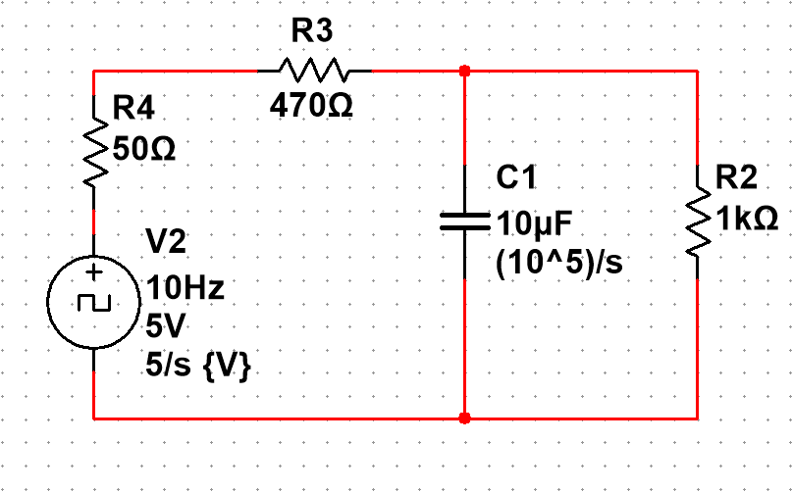**Step Response:**

*i2*

*i1*

***Fig1. “s-domain step response equivalent circuit with mesh loop currents i1(s) and i2(s)”***

* + The s-domain equations for the step response loop currents c are as follows:
$$i_{1}\left(s\right)= \frac{s+100}{8⋅s⋅(13⋅s+3800)} \{A\}$$

$$i_{2}\left(s\right)= \frac{25}{2⋅s⋅(13⋅s+3800)} \{A\}$$

* **Natural Response:**

*i2*

*i1*

***Fig2. “s-domain natural response equivalent circuit with mesh loop currents i1(s) and i2(s)”***

* + The s-domain equations for the natural response loop currents i1(s) and i2(s) are as follows:

$$i_{1}\left(s\right)= \frac{25}{3952⋅(s+\frac{3800}{13})} \{A\}$$

$$i_{2}\left(s\right)= \frac{13}{3952⋅(s+\frac{3800}{13})} \{A\}$$

1. **Time-domain Solutions:**

* **Step Response:**
$$i_{1}\left(t\right)= \frac{25}{3952}e^{-\frac{3800}{13}t}+\frac{1}{304} \{A\}$$

$$i_{2}\left(t\right)= -\frac{1}{304}e^{-\frac{3800}{13}t}+\frac{1}{304} \{A\}$$

* **Natural Response:**

$$i_{1}\left(t\right)= \frac{25}{3952}e^{-\frac{3800}{13}t} \{A\}$$

$$i_{2}\left(t\right)= \frac{1}{304}e^{-\frac{3800}{13}t} \{A\}$$

1. **Output Expressions:**

* **Step Response (Current):**
$$i_{C}\left(t\right)= i_{1}(t)-i_{2}(t) \{A\}$$

$$i_{C}\left(t\right)= \frac{1}{104}e^{-\frac{3800}{13}t} \{A\}$$

* **Natural Response (Current):**
$$i_{C}\left(t\right)= i_{1}(t)-i_{2}(t) \{A\}$$

$$i_{C}\left(t\right)= -\frac{1}{104}e^{-\frac{3800}{13}t} \{A\}$$

* **Step Response (Voltage):**
$$V_{C}\left(t\right)= \frac{1000}{104}e^{-\frac{3800}{13}t} \{V\}$$

* **Natural Response (Voltage):**

$$V_{C}\left(t\right)= -\frac{1000}{104}e^{-\frac{3800}{13}t} \{V\}$$

**Experimental Procedure and Results:**

* 1. **Setup Description:**
  + The oscilloscope was set to a step voltage of 5Vpk-pk source with a frequency of 10Hz and an offset of +2.5 Volts. This source was then connected to the circuit in figure 1 and it was also connected (by aid of a t-splitter) to a oscilloscope to we could track how the circuit changes over time. The oscilloscope was also measured the voltage across the 1kΩ resistor so that we could subtract the voltage across the 1kΩ resistor from the voltage source to find the voltage drop across the 470Ω resistor.
  1. **Waveform Plots:**
* **i1(t):**

***Fig3. “Graph of i1(t) showing both the step response and natural response of the current through the 470Ω resistor”***

* 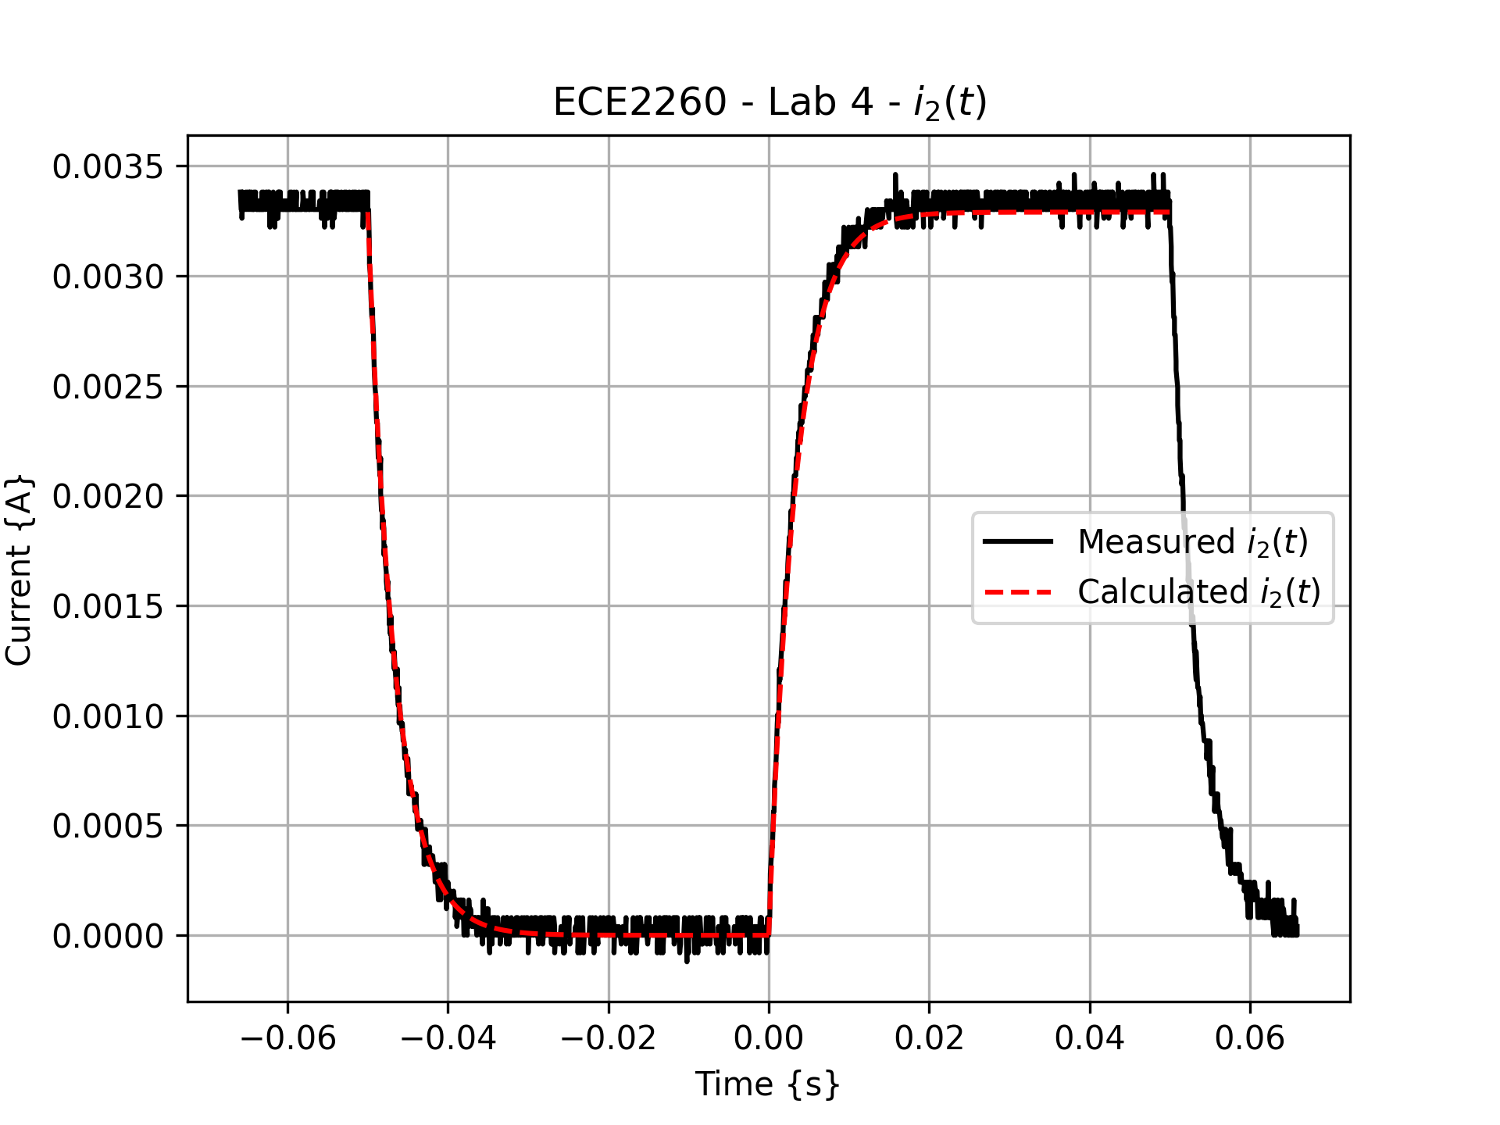**i2(t):**

***Fig4. “Graph of i2(t) showing both the step response and natural response of the current through the 1kΩ resistor”***

* A graph of a graph showing a measurement

  AI-generated content may be incorrect.**iC(t):**

***Fig5. “Graph of iC(t) showing both the step response and natural response of the current through the capacitor”***

* 1. **Quantitative Comparisons:**
* The decay rate between the analytical curves and the measured curves for my graphs are almost identical. The only discrepancy that I noticed is that in figure 4 the analytical solution does not peak as high as we had measured in with our oscilloscope. For this lab we it is good enough that the decay rates and peaks of the data are as close as they are.
* The steady-state values at the end of each half-cycle were very close to the values we expected from the measured data. As previously stated, the eventual steady-state value for the i2(t) rising to its peak was a little low but nothing that would not have been due to component value discrepancies as well as maybe a little operator error.
* We see the sudden negative spike in the capacitor when the voltage source shorts but the capacitor still has stored voltage. Using the MATH function on the oscilloscope and subtracting CH2 (voltage across the 1kΩ resistor) from CH1 (source) we will get a negative spike because the resistor still has a voltage across it due to the voltage stored in the capacitor. This spike will eventually decay away as the voltage is dissipated.

**Conclusion:**

Thanks to the Laplace analysis of this circuit we were able to figure out how this two loop mesh-analysis RC circuit responded in a transient-source situation. We saw that the capacitor contributed to the voltage in the circuit in such a way that caused a sudden negative spike in voltage when the square-wave input because the integrodifferential equations that govern the laws of physics in this world that we live in. These equations as well as the way that we calculated the current going through the capacitor (CH1-CH2) resulted in that negative spike. It is important to understand the transient response behavior in an RC circuit as well as the utility of the s-domain because of how we may want a circuit to react to changes in voltage that it receives. Diving into the realm of transfer functions and filters we may want a specific circuit to react a specific way to the voltage it receives.